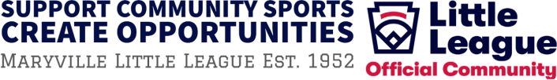

2022 Community Sports Sponsorship Opportunities

|  |  |
| --- | --- |
| **Outfield Banner Packages** | |
|  | **GOLD SPONSORSHIP $1,500**  One (1) 6' x 12', full-color dugout banner with company name and logo  Two (2) 4' x 6', full-color outfield banners with company name and logo Recognition on the Maryville Little League website |
|  | **SILVER SPONSORSHIP $700**  Two (2) 4' x 6', full-color outfield banners with company name and logo Recognition on the Maryville Little League website |
|  | **BRONZE SPONSORSHIP $400**  One (1) 4' x 6', full-color outfield banners with company name and logo  Recognition on the Maryville Little League website |

**Annual Discount Card**

# Offer on our annual Discount Card (April 1, 2022-March 31, 2023)

## Enter Exact Wording Here (limited to 40 characters including spaces)

______________________________________________________________________

______________________________________________________________________

______________________________________________________________________

______________________________________________________________________

Please make checks payable to Maryville Little League

Mail to PO Box 4096 Maryville, TN 37802

**Thank you for supporting recreational sports for our Blount County youth!**

## Tel: 865.310.7683 (Tabitha Hasty, Board President) Local Web [www.maryvillelittleague.com](http://www.maryvillelittleague.com/)

Email: [maryvillelittleleague@gmail.com](mailto:maryvillelittleleague@gmail.com) National Web: [www.littleleague.com](http://www.littleleague.com/)